

Instructions for Adlumin Agent Repair via N-sight
May 14, 2025
V 1.0

Summary:
Instructions for the deployment of a scripted fix for Adlumin Agents installed on Windows OS that are not currently registering to Adlumin servers but has done so previously. If an Adlumin Agent has never been installed on the target device or has been cleanly uninstalled this repair script will fail.

Step 1:
Download the Automation Manager Policy (.amp) file here.
OPTIONAL - Verify the hash of the .amp. If MD5 hash value does not match ensure you have access to most recent version of documentation and .amp file
MD5 - B7507698F11687CEDADAEC25FF063E67

Step 2:
Navigate to Settings > Script Manager in N-sight dashboard

Step 3:
From the Script Manager window select New in the top left to add a new User Defined Script. Enter the following fields and selections.
Name: Adlumin Agent Repair
Description: Repair Adlumin agents via uninstall and reinstall
Type: Automated Task
OS: Windows
Click the Browse button under Upload a Script and select the ‘Adlumin Agent Repair.amp” file you download in Step 1.
Click Save on the Add User Defined Scripts window to save the amp file to the N-sight Script Manager

Step 4:
Right click the Client or Site on the left navigation pane and select Task > Add
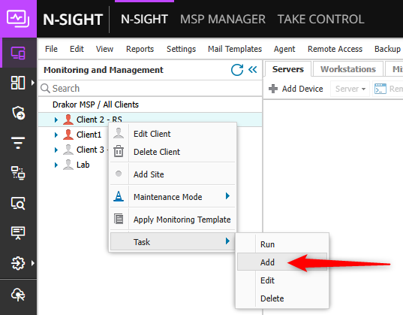

In the Add Automated Task window search for the Adlumin Agent Repair you uploaded in Step 3 and click Next
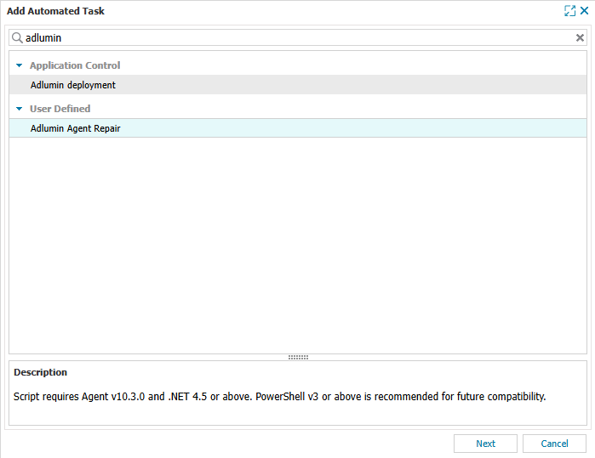
Select the devices types you want to add the task to
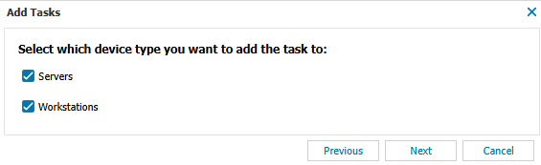

Enter the Adlumin TenantID for the Adlumin tenant that target devices should be joined to click next.
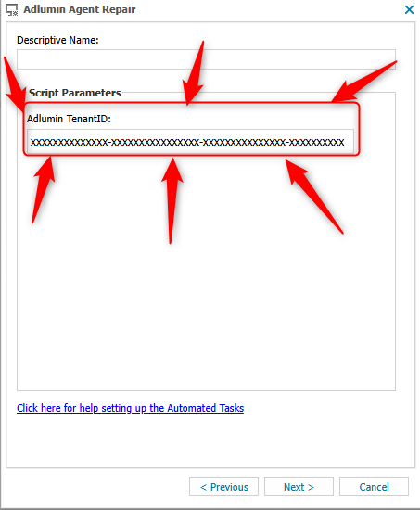
Warning: Failure to input a valid Adlumin TenantID may result in unpredictable behaviors

On the Select Frequency Method window select Manual from the dropdown menu and select next.
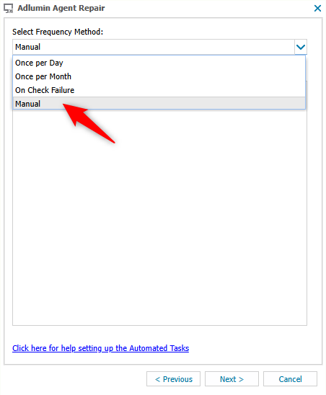

On the Options window leave the Set maximum permitted execution time box checked with the default of 1 hour.

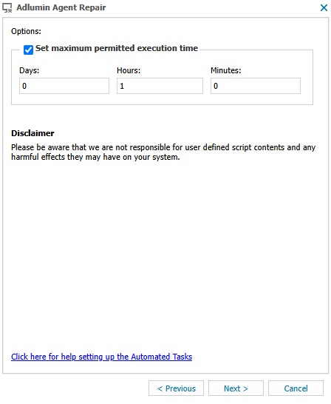

Select the devices to target with the Adlumin Agent Repair in the Add Task Device Confirmation window and click Add Task button.
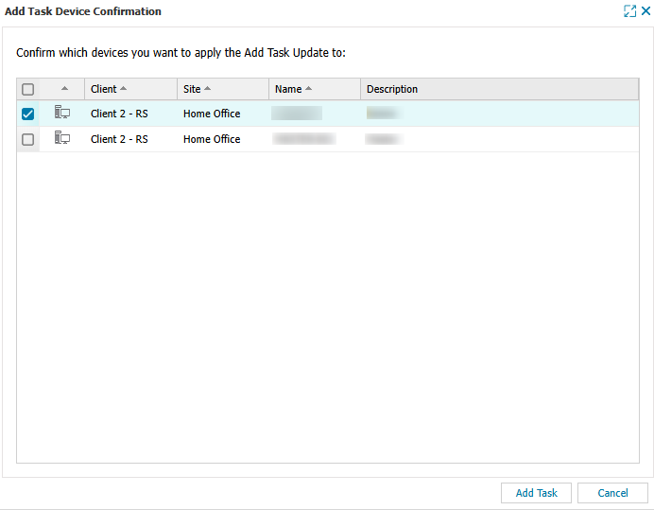

Step 5:
In the left navigation pane right click the Client or Site and select Task > Run
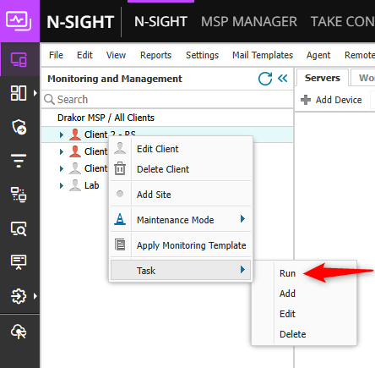

In the Run Tasks window select the Adlumin Agent Repair for the device types you wish to target for this Client or Site and click Next
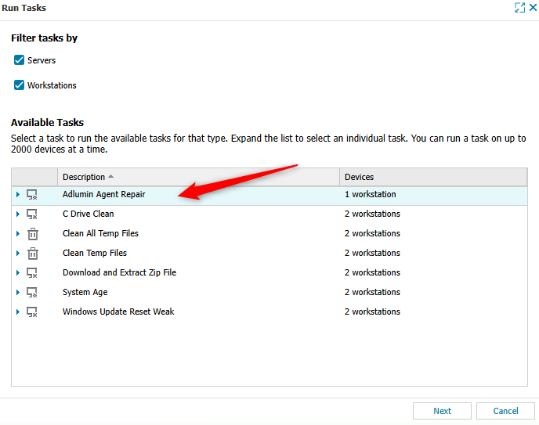

Confirm the devices that will be targets for the Adlumin Agent Repair script and click Run Task.

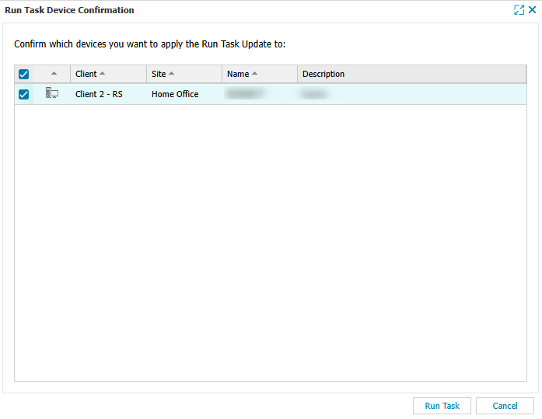
Step 6:
Allow time for script to run and then verify Adlumin agents are running and are sending information to the Adlumin server.

