

Instructions for Adlumin Agent Repair via N-central
May 14, 2025
V 1.0

Summary:
Instructions for the deployment of a scripted fix for Adlumin Agents installed on Windows OS that are not currently registering to Adlumin servers but has done so previously. If an Adlumin Agent has never been installed on the target device or has been cleanly uninstalled this repair script will fail.

Step 1:
Download the Automation Manager Policy (.amp) file here.
OPTIONAL - Verify the hash of the .amp. If MD5 hash value does not match ensure you have access to most recent version of documentation and .amp file
MD5 - B7507698F11687CEDADAEC25FF063E67

Step 2:
In your N-central dashboard select the target Service Organization from the left nav bar. Do not select ‘System’ if it is available.
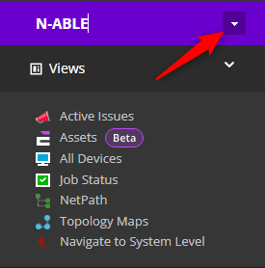

Step 3:
Navigate to Configuration > Scheduled Tasks > Script/Software Repository and select “Automation Policy” from the Add dropdown menu.
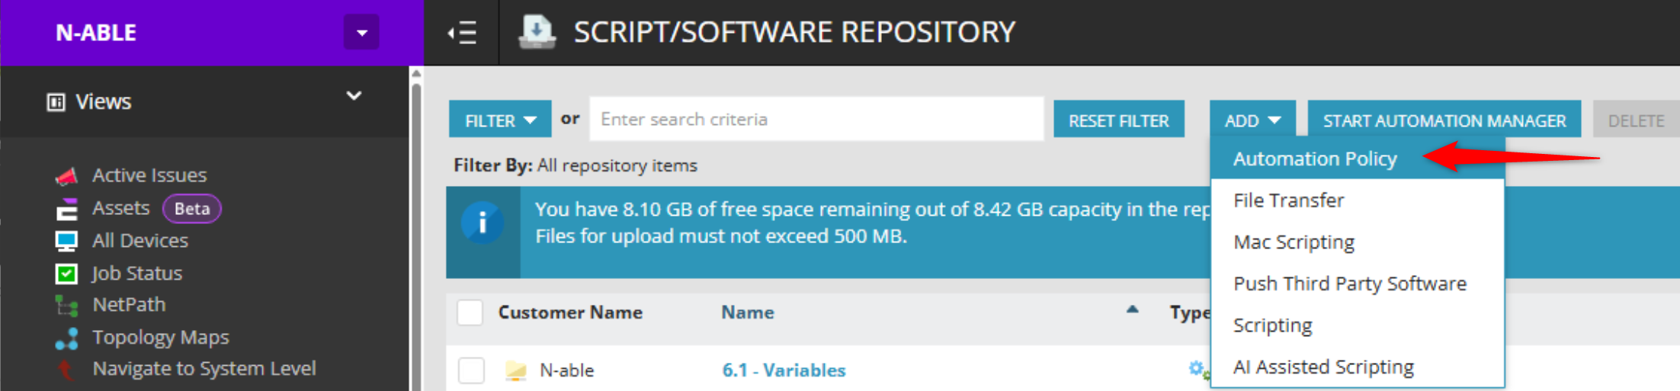

Step 4:
From the ADD SCRIPT/SOFTWARE REPOSITORY ITEM screen choose Browse and select the .amp file you downloaded in Step 1.

Step 5:
Navigate to Actions > Run an Automation Policy.
On the Details tab select the amp file you added to the Script Repository in Step 4. You MUST input the Adlumin TenantID from your Adlumin dashboard for the appropriate tenant.
On the Targets tab select the Filter or Devices to target
On the Schedule tab choose when you would like the Automation Policy to run.
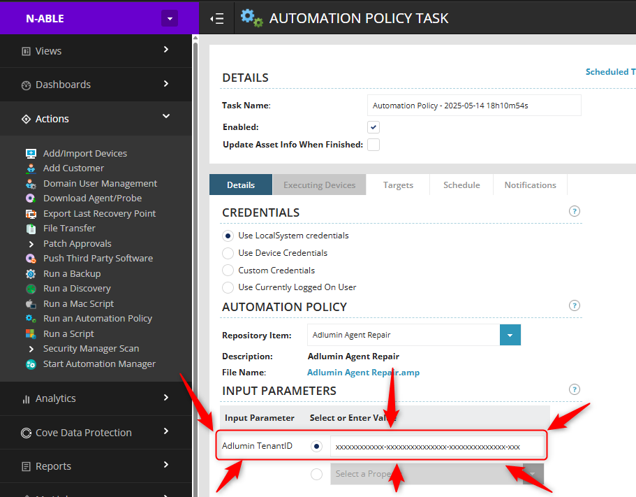
Warning: Failure to input a valid Adlumin TenantID may result in unpredictable behaviors

Step 6:
Allow time for script to run and then verify Adlumin agents are running and are sending information to the Adlumin server.

